<COMPANY LETTERHEAD>

<DATE>

Director – Research School of Engineering

College of Engineering and Computer Science

Australian National University

Canberra, ACT 0200

**LETTER OF DECLARATION RE URI PIERRE BURMESTER PRACTICAL EXPERIENCE**

To whom it may concern,

Uri Pierre Burmester is a member of staff at Questacon – The National Science and Technology Centre and is seeking to count his employment as a Gallery Assistant toward the Practical Experience (ENGN3100) component of his Bachelor of Engineering (Hons.). Though Uri is not employed at Questacon in an engineering context, his environment is suitable to:

I. expose him to the workplace and workplace issues (such as human and industrial relations, job organisation, maintenance, safety and environmental issues).

This is to certify that while working at Questacon under the supervision of Jessica Brosnan, the following minimum set of Stage 1 competencies will be manifested in the work performed and in a manner that can be documented by Mr Uri Pierre Burmester.

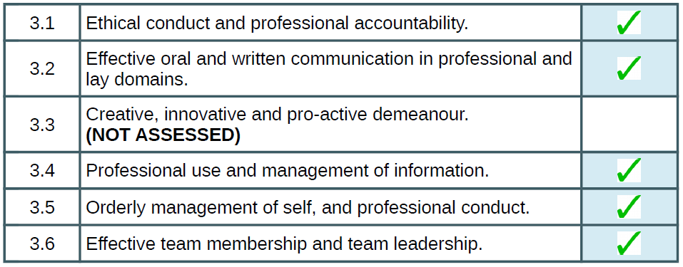

Yours Sincerely,

<SIGNATURE>

Jessica Brosnan

Front of House Duty Manager, Questacon